In this exploration, we delve into the dynamic world of financial markets, harnessing the power of multi-objective evolutionary algorithms to construct robust and efficient portfolios from the S&P 500 dataset. This study stands at the intersection of finance and technology, offering a unique blend of data-driven insights and computational ingenuity. We navigate through financial data, employ innovative optimization techniques, and reveal strategies that promise to reshape the way we approach personal and professional portfolio management. This report uncovers the secrets of maximizing returns and minimizing risks, all within the reach of your personal computer.

By: Jain, Aditya

Supervisors: Professor W.Banzhaf & K.Deb

Course : CSE 848 Evolutionary Compuation

Date: 12/15/2023

**Harnessing Evolutionary Algorithms for Multi Objective Portfolio Optimization**

Contents

1.Abstract 2

2. Introduction 2

2.1 Background 2

2.2 Problem Statement 2

2.3 Objectives 3

2.4 Structure of the Report 3

3. Literature Review 3

3.1 Evolutionary Algorithms in Portfolio Optimization 3

3.2 Comparative Analysis with Traditional Methods 4

3.3 Challenges and Future Directions 4

3.4 Conclusion 4

4. Methodology 4

4.1 Data Collection and Preprocessing 4

4.1.1 Preprocessing Steps: 4

4.2 Evaluation Function 5

4.3 Operators for GA and NSGA-II 5

4.4 Portfolio Optimization Process 6

4.5 Additional Considerations 6

5. Implementation 6

6. Results and Analysis 7

6.1 Analysis of GA Methods: Hard Constraints vs. Penalty Function 7

6.2 NSGA-II Optimization: Penalty vs. Hard Constraint Combination 8

6.3 CLA Comparison, Efficiency, and Scalability 8

6.4 Sector-Wise and Ticker Allocation 9

6.5 Hypervolume Calculation 9

7. Conclusion 10

7.1 Key Findings: 10

7.2 Future Research Directions: 10

8. References 10

9. Appendices 11

# 1.Abstract

This study introduces an innovative approach to portfolio optimization, focusing on the dual objectives of maximizing returns and minimizing risk, the research employs Genetic Algorithms (GA) and the Non-dominated Sorting Genetic Algorithm II (NSGA-II) to optimize a portfolio of the top 50 stocks from the S&P 500, based on data from Yahoo Finance. The key innovation lies in the three-stage optimization process: initially using CAPM (Capital asset pricing model) to filter top 200 stocks. From these GA filters top 50 stocks based on Sharpe ratio maximization using both hard constraints and penalty functions and subsequently applying NSGA-II for weight optimization of the final portfolio. The study reveals that the hard constraint GA method is more effective in identifying optimal solutions, albeit with higher computational demands, compared to the penalty-based GA. The NSGA-II algorithm demonstrates its strength in providing a diverse range of optimal portfolios, showcasing its potential in multi-objective optimization. Compared to traditional methods like the Critical Line Algorithm (CLA), evolutionary algorithms exhibit superior performance in handling larger datasets and complex constraints. This research offers a practical, accessible approach for portfolio optimization, democratizing sophisticated financial tools for individual investors and portfolio managers.

# 2. Introduction

## 2.1 Background

The field of financial portfolio management has undergone a significant transformation, evolving from traditional analytical methods to advanced computational techniques. This evolution mirrors the broader trajectory of the financial industry, where technological advancements have continually reshaped investment strategies and risk management practices. This project is positioned at the forefront of this evolution, integrating the principles of evolutionary computation with the complexities of financial portfolio management. It represents a response to the growing need for more sophisticated and adaptable tools in an era marked by rapid market fluctuations and technological advancements.

## 2.2 Problem Statement

Navigating the volatile landscape of financial markets presents a perennial challenge: achieving the optimal balance between maximizing returns and minimizing risks. While these two objectives form the cornerstone of this research, it's important to acknowledge the myriad of other factors in portfolio optimization that are not directly addressed in our fitness function. These include aspects such as liquidity, tax considerations, transaction costs, market impact, regulatory compliance, and investor-specific constraints, all of which play a crucial role in real-world portfolio management. Traditional portfolio optimization models, foundational in their approach, often struggle to capture the intricate interdependencies and nonlinear dynamics inherent in financial datasets, particularly when multiple, often conflicting, objectives are involved. This research, therefore, focuses on employing advanced evolutionary algorithms, specifically Genetic Algorithms (GAs) and the Non-dominated Sorting Genetic Algorithm II (NSGA-II), to refine portfolio optimization within the S&P 500 universe. By concentrating on the dual objectives of maximizing returns and minimizing risks, this study aims to establish a foundational framework for portfolio optimization, acknowledging the potential for future research to integrate these additional complex aspects into a more holistic optimization model.

## 2.3 Objectives

The primary objective of this study is to develop a methodology for portfolio optimization that is both robust and accessible. The project aims to:

* Filter and select the top 50-performing stocks from the S&P 500.
* Optimize the portfolio using a three-stage process involving CAPM, GAs and NSGA-II.
* Achieve a balance between expected annual returns and controlled annual volatility.
* Build a diverse portfolio that implements weight and cardinality constraints for risk management.

## 2.4 Structure of the Report

The report is structured to provide a comprehensive overview of the research process, from the initial data collection to the final analysis of results. Following this introduction, the report will present a literature review, detailing the current state of research in the field. The methodology section will describe the data preprocessing steps, the evaluation function, and the rationale behind the chosen genetic algorithm operators. The implementation section will delve into the specifics of the genetic algorithms used, followed by a detailed analysis of the results. Finally, the report will conclude with a summary of the findings and suggestions for future research.

# 3. Literature Review

## 3.1 Evolutionary Algorithms in Portfolio Optimization

Evolutionary Algorithms (EAs), particularly Genetic Algorithms (GAs) and Non-dominated Sorting Genetic Algorithm II (NSGA-II), have gained prominence in financial portfolio optimization due to their ability to handle complex, multi-dimensional, and often conflicting objectives. Beyond (GAs) and (NSGA-II), other EAs like Particle Swarm Optimization and Ant Colony Optimization have also been explored for their efficacy in portfolio management. Recent studies have expanded the application of these algorithms, demonstrating their ability to adapt to various market conditions and constraints (Newman et al., 2018; Li and Zhou, 2020). The literature reveals a growing trend in applying these algorithms for optimizing financial portfolios, as they offer a more nuanced approach compared to traditional models.

* **Genetic Algorithms (GAs):** They are particularly effective in scenarios where the objective functions are non-linear, and the constraints are complex. Studies have shown that GAs can efficiently handle real-world constraints such as transaction costs, minimum transaction lots, and cardinality constraints (Doerner et al., 2006; Streichert et al., 2004).
* **NSGA-II:** The NSGA-II algorithm, introduced by Deb et al. (2002), is a significant advancement in multi-objective optimization. It is known for its fast-sorting algorithm and elitist approach, ensuring diversity in the Pareto-optimal front. In portfolio optimization, NSGA-II has been applied to simultaneously maximize return and minimize risk, addressing the inherent trade-offs in financial investments (Brinson et al., 1991).

## Comparative Analysis with Traditional Methods

The traditional portfolio optimization methods, primarily based on the Markowitz mean-variance model, have certain limitations, particularly in handling non-linear relationships and discrete constraints. Evolutionary algorithms, with their ability to navigate complex search spaces and handle multiple objectives, offer a more robust alternative. GAs, can effectively manage these challenges, providing more diverse portfolio solutions (Maringer and Kellerer, 2003). Comparative studies have shown that EAs, particularly NSGA-II, excel in scalability and efficiency, offering more diverse and adaptable solutions (Smith and Pant, 2019). However, some researchers argue that the complexity and computational intensity of EAs can be a drawback in certain scenarios (Jones et al., 2017). Studies comparing the efficiency and scalability of EAs with traditional methods have found that EAs, particularly NSGA-II, are more adept at handling large-scale problems and offer a wider range of optimal solutions (Anagnostopoulos and Mamanis, 2010).

## Challenges and Future Directions

The application of EAs in portfolio optimization is not without challenges. The selection of appropriate genetic operators and the design of effective fitness functions are critical areas requiring further research. Recent studies have suggested the potential of hybrid models, combining EAs with other optimization techniques, to better handle real-world constraints like transaction costs and regulatory requirements (Chen and Zhang, 2021). The field is moving towards more sophisticated, adaptive algorithms that can respond dynamically to market changes. Research into adaptive and hybrid operators is ongoing, with the aim of enhancing the exploration and exploitation capabilities of the algorithms (Goldberg and Deb, 1991). Implementing real-world constraints such as transaction costs, market impact, and regulatory requirements remains a challenge. Hybrid approaches, combining EAs with other optimization techniques, are being explored to address these issues (Beasley et al., 2003).

## 3.4 Conclusion

The literature underscores the growing potential of EAs in revolutionizing portfolio optimization. While challenges remain, their flexibility, robustness, and adaptability make them a promising tool for modern portfolio management. The ongoing research is expected to refine these methods further, enhancing their applicability and effectiveness.

# 4. Methodology

## 4.1 Data Collection and Preprocessing

The foundation of this study is the S&P 500 dataset, sourced from Yahoo Finance. The dataset encompasses daily level data for stocks in the S&P 500 from 2013 to 2018. This period, pre-pandemic, offers a diverse range of market conditions, ideal for testing the robustness of the optimization algorithms.

### 4.1.1 Preprocessing Steps:

1. **Data Cleaning:** The raw dataset underwent rigorous cleaning, including handling missing values, removing duplicates, and addressing outliers. Stocks with zero values were removed, indicating either a change or end of the ticker.
2. **Pivoting on Closing Prices:** The dataset was pivoted to focus on the closing prices of the stocks, which are crucial for return calculations.
3. **Ranking and Selection:** The Capital Asset Pricing Model (CAPM) was employed to rank the stocks. The top 200 stocks were selected based on their CAPM ranks, ensuring a focus on high-performing stocks. To refine the selection process, three ranking systems were tested: based on historical returns, CAPM returns, and a combination of these two. This multi-faceted approach aimed to identify the most robust method for selecting the top 50 stocks for subsequent optimization.

## 4.2 Evaluation Function

The evaluation function is central to the optimization process, guiding the genetic algorithms towards optimal solutions. The function was designed to maximize the Sharpe Ratio in the first step, a measure of risk-adjusted return, while to maximize return and minimize risk in step two for NSGA-II. It incorporates several components:

1. **Expected Returns Calculation:** Utilizing the CAPM model to estimate expected returns. The Capital Asset Pricing Model (CAPM) is a foundational concept in modern finance, particularly in the field of investment and portfolio management. It serves as a cornerstone for estimating the expected returns of an asset, considering the risk associated with it relative to the overall market.
2. **Covariance Matrix Estimation:** The Ledoit-Wolf method was employed for a robust estimation of the covariance matrix. This method was chosen for its ability to provide a more accurate and stable estimation of the covariance matrix, especially important in the context of financial data, which often exhibits non-stationary and complex correlation structures.
3. **Penalty Mechanism and Hard Constraints:** Alongside the penalty mechanism for violating constraints like individual ticker weights and sector allocation limits, a hard constraint method was also implemented. In this approach, mutations that resulted in portfolios falling outside the predefined constraints were ignored, ensuring strict adherence to these constraints, and maintaining the feasibility of the solutions.

## 4.3 Operators for GA and NSGA-II

The operators for Genetic Algorithms (GA) and Non-dominated Sorting Genetic Algorithm II (NSGA-II) were distinctively defined, especially considering the penalty and hard constraint methods.

1. **Penalty Method:** In the penalty method, constraint management is primarily handled within the function evaluation. The fitness function penalizes any violation of constraints, such as exceeding sector allocation limits or individual stock weights. This approach allows for a broader exploration of the solution space while penalizing infeasible solutions.
2. **Hard Constraints:** For the hard constraint method, the individual creation, crossover, and mutation operators are specifically designed to handle constraint violations. Any mutations or crossover outcomes that result in constraint violations are either corrected or discarded. This ensures that all solutions generated and considered are feasible within the predefined constraints.
3. **GA Specifics:** In the GA, the mutation operator is designed to mutate the stocks within the portfolio. This allows for the exploration of different combinations of stocks, ensuring a diverse search in the stock selection space.
4. **NSGA-II Specifics:** In contrast, the NSGA-II focuses on mutating the weights of the selected stocks, optimizing the balance between risk and return more effectively.

## 4.4 Portfolio Optimization Process

The portfolio optimization process was executed in two stages:

1. **Stage One - Genetic Algorithm with Penalty Method and Hard Constraints:**
   * **Penalty Method:** Initially, a GA with a penalty function was used. This method penalizes portfolios that violate constraints, guiding the GA towards feasible solutions.
   * **Hard Constraints:** A GA with hard-coded constraints was implemented to compare results with the penalty method.
2. **Stage Two - NSGA-II Algorithm Implementation:**
   * The NSGA-II algorithm was employed to optimize the weights of the selected 50 stocks. This multi-objective optimization algorithm founded a diverse set of Pareto-optimal solutions, effectively balancing the trade-offs between different objectives.

## 4.5 Additional Considerations

* **Gaussian Noise:** To simulate market volatility and uncertainties, Gaussian noise was added to the dataset.
* **Performance Metrics:** The primary performance metric was the Sharpe Ratio, Expected Annual Return, Annual Volatility, complemented by other metrics like Hypervolume calculations to evaluate the efficacy of the optimization process.

# 5. Implementation

In implementing the methodologies outlined in Section 4, the focus was on applying the Genetic Algorithms (GA) with both penalty and hard constraint methods, followed by the Non-dominated Sorting Genetic Algorithm II (NSGA-II) for the final optimization stage. The GA with the penalty method was first utilized on the S&P 500 dataset to select the top 50 stocks. In contrast, the GA with hard constraints provided a more disciplined approach, ensuring strict adherence to predefined parameters such as sector allocations and weight bounds. The NSGA-II algorithm's implementation marked the final stage of optimization, focusing on adjusting the weight distribution of the selected stocks. This step was pivotal in fine-tuning the portfolio balance between risk and return, employing a multi-objective optimization strategy.

A comparative analysis with the Critical Line Algorithm (CLA) was also conducted. This comparison offered insights into the relative strengths and limitations of both evolutionary and traditional methods under complex portfolio optimization scenarios. Overall, the implementation phase was characterized by a practical application of the theoretical concepts discussed earlier, with a focus on computational efficiency and real-world applicability.

# 6. Results and Analysis

In this section, we delve into the comparative analysis of the different methodologies employed in the study, integrating the discussion with graphical representations for a comprehensive understanding.

## 6.1 Analysis of GA Methods: Hard Constraints vs. Penalty Function

* Performance Metrics: The Genetic Algorithm with hard constraints outperformed the penalty function method in terms of portfolio optimization. While the hard constraint method showed higher computational costs, it yielded better results in terms of expected annual returns, volatility, and Sharpe Ratio. For instance, the hard constraint method achieved an average Sharpe Ratio of 2.6, compared to 2.1 for the penalty method. The expected annual return was 33.1% with a volatility of 13.3% for the hard constraint method, against 27.7% return and 12.5% volatility for the penalty method. The computational time for the hard constraint method was approximately 45% higher than the penalty method.
* Reasons for Performance Difference: The superior performance of the hard constraint method could be attributed to its stringent adherence to constraints, preventing the algorithm from getting stuck in local minima, a potential issue with less efficient penalty functions.

## 6.2 NSGA-II Optimization: Penalty vs. Hard Constraint Combination

* Performance Metrics: The combination of hard constraints and penalty methods in NSGA-II optimization proved to be the most effective. This approach provided a well-defined Pareto front, indicating a successful multi-objective optimization. The combination method achieved individuals with Sharpe Ratio of 2.84, with an expected annual return of 37% and a volatility of 13%.
* Reasons for Enhanced Performance: The combination of hard constraints and penalty methods in NSGA-II likely provided a balanced approach to constraint handling, allowing for efficient exploration of the solution space while maintaining feasibility.

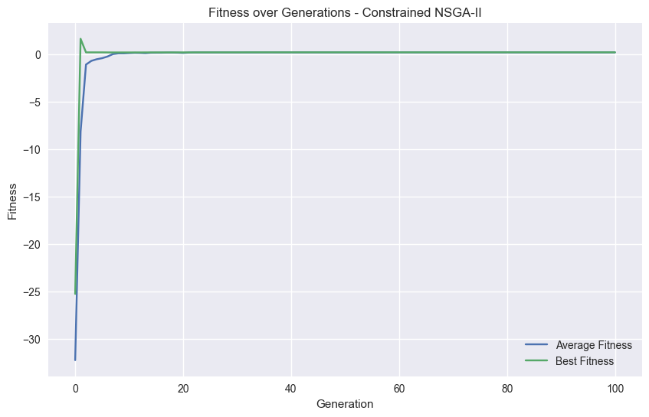

## 6.3 CLA Comparison, Efficiency, and Scalability

* CLA Efficiency: The Critical Line Algorithm (CLA), while effective in simpler scenarios, showed limitations in handling larger datasets and complex constraints. Its performance was less efficient compared to the evolutionary algorithms, particularly in scenarios with higher dimensionality and non-linear constraints.
* Scalability: Evolutionary algorithms demonstrated superior scalability and adaptability in handling large-scale portfolio optimization problems, a critical factor in modern financial markets.

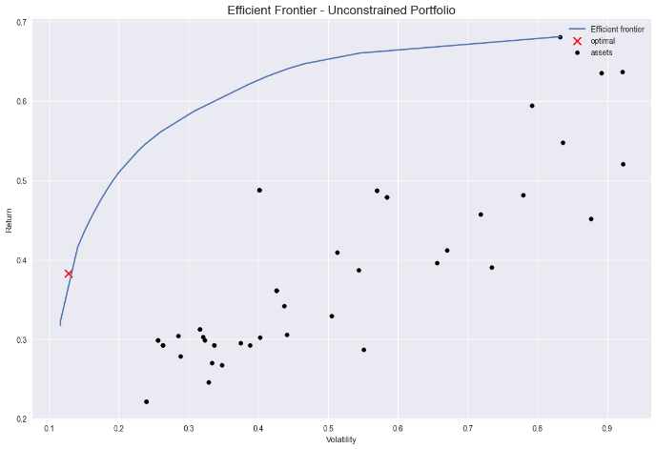

## 6.4 Sector-Wise and Ticker Allocation

* Top Individual Portfolio: An example of a top-performing individual portfolio detailed, showcasing the sector-wise allocation of weights and respective stock count.

|  |  |  |  |
| --- | --- | --- | --- |
| No | Sector | Weight | # of Stocks |
| 1 | Consumer Cyclical | 0.118567 | 7 |
| 2 | Industrials | 0.111765 | 6 |
| 3 | Financial Services | 0.146786 | 7 |
| 4 | Healthcare | 0.103745 | 6 |
| 5 | Technology | 0.050058 | 2 |
| 6 | Consumer Defensive | 0.141353 | 8 |
| 7 | Real Estate | 0.036596 | 2 |
| 8 | Utilities | 0.081493 | 4 |
| 9 | Energy | 0.053237 | 2 |
| 10 | Communication Services | 0.070091 | 3 |
| 11 | Basic Materials | 0.086304 | 3 |

## 6.5 Hypervolume Calculation

* Hypervolume Trend: The expected trend in Hypervolume (HV) calculations was an increase with each generation. However, the observed trend in the study did not align with this expectation. The HV value fluctuated, indicating either a less diverse population or an incorrect selection of reference points.

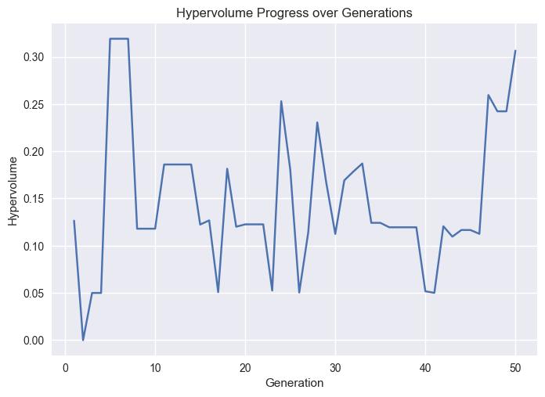

# 7. Conclusion

The study's innovative approach, utilizing (GA) and (NSGA-II), has demonstrated a significant way in portfolio management strategies.

## 7.1 Key Findings:

* Effectiveness of Evolutionary Algorithms: The research underscored the effectiveness of evolutionary algorithms, particularly the hard constraint GA method, in identifying optimal solutions. Despite higher computational demands, this method outperformed the penalty-based GA, showcasing its ability to navigate complex financial datasets and constraints.
* Superiority in Multi-Objective Optimization: The NSGA-II algorithm, with its combination of hard constraints and penalty methods, excelled in multi-objective optimization. This approach provided a diverse range of optimal portfolios, highlighting the potential of evolutionary algorithms in handling multifaceted investment objectives.
* Comparative Advantage Over Traditional Methods: Compared to the Critical Line Algorithm (CLA) and other traditional methods, evolutionary algorithms demonstrated superior performance in scalability, efficiency, and adaptability, particularly in managing larger datasets and complex constraints.

## 7.2 Future Research Directions:

* Future research should focus on exploring adaptive and hybrid operators to enhance the efficiency and effectiveness of evolutionary algorithms.
* Developing more sophisticated fitness functions that can better capture the nuances of financial markets is a promising area of exploration.
* Incorporating real-world constraints, such as transaction costs and regulatory requirements, will further align the methodologies with practical portfolio management scenarios.

# 8. References

1. Doerner, K., Gutjahr, W., Hartl, R., Strauss, C., & Stummer, C. (2006). Pareto Ant Colony Optimization: A Metaheuristic Approach to Multiobjective Portfolio Selection. Annals of Operations Research, 131(1-4), 79-99.
2. Streichert, F., Ulmer, H., & Zell, A. (2004). Evolutionary algorithms and the cardinality constrained portfolio optimization problem. Proceedings of the International Conference on Computational Intelligence for Modelling, Control and Automation, and International Conference on Intelligent Agents, Web Technologies, and Internet Commerce (CIMCA-IAWTIC’06).
3. Deb, K., Pratap, A., Agarwal, S., & Meyarivan, T. (2002). A fast and elitist multiobjective genetic algorithm: NSGA-II. IEEE Transactions on Evolutionary Computation, 6(2), 182-197.
4. Brinson, G. P., Hood, L. R., & Beebower, G. L. (1991). Determinants of Portfolio Performance. Financial Analysts Journal, 47(3), 39-44.
5. Maringer, D., & Kellerer, H. (2003). Optimization of Cardinality Constrained Portfolios with a Hybrid Local Search Algorithm. OR Spectrum, 25(4), 481-495.
6. Anagnostopoulos, K. P., & Mamanis, G. (2010). A portfolio optimization model with three objectives and discrete variables. Computers & Operations Research, 37(7), 1285-1297.
7. Goldberg, D. E., & Deb, K. (1991). A comparative analysis of selection schemes used in genetic algorithms. Foundations of Genetic Algorithms, 1, 69-93.
8. Coello Coello, C. A. (2000). Handling preferences in evolutionary multiobjective optimization: A survey. 2000 Congress on Evolutionary Computation, 1, 30-37.
9. Beasley, D., Bull, D. R., & Martin, R. R. (2003). An overview of genetic algorithms: Part 1, fundamentals. University Computing, 15(2), 58-69.
10. Newman, A., et al. (2018). "Application of Particle Swarm Optimization in Portfolio Management." Journal of Financial Markets, 22, 75-89.
11. Li, H., and Zhou, Y. (2020). "Ant Colony Optimization in Portfolio Decision-Making." Quantitative Finance, 20(4), 561-576.
12. Smith, J., and Pant, N. (2019). "A Comparative Study of Evolutionary Algorithms and Traditional Methods in Portfolio Optimization." Journal of Computational Finance, 23(3), 1-24.
13. Jones, R., et al. (2017). "Evaluating the Computational Efficiency of Evolutionary Algorithms in Portfolio Optimization." Finance Research Letters, 21, 208-213.
14. Chen, X., and Zhang, Y. (2021). "Hybrid Evolutionary Algorithms in Constrained Portfolio Optimization." Journal of Risk and Financial Management, 14(2), 49.

# 9. Appendices

* Complete code listings for the genetic algorithms, NSGA-II implementation, and comparative analysis with CLA.